Product description
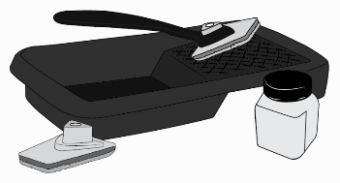
EQUITONE [natura] and [natura] PRO have semi transparant coatings. The cut edges of these panels need a treatment with an impregnating transparent agent LUKO.

ARTICLE NUMBER: See page 2

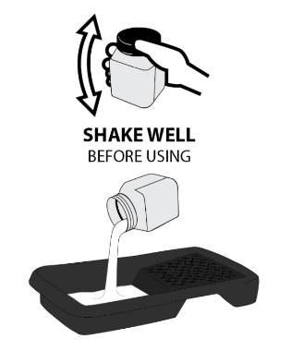
1. Technical Characteristics
Delivery form | ready for use
View | milky liquid
LUKO tools
LUKO paint-tray for 0.5 L + applicator with special microfiber cloth (5 x 8 cm)

2. Instructions for use
Shake well before use and shake regularly while using (demixing can appear). The LUKO impregnating agent is used undiluted.

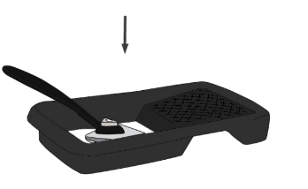
LUKO must be applied only in a dry environment. The ambient temperature for application of LUKO should be between 5 °C and 25 °C. For temperatures above 25 °C, LUKO tends to dry prematurely and hence extra coats are highly recommended to fully cover the panel edges.

After sanding the edges of the panel, remove all dust from the edges.

Simply pour only enough LUKO into the clean tray that can be used within 30 mins. Do not pour any leftover LUKO back into the container.
Dip the applicator into LUKO. Wipe the applicator on the surface of the paint tray to prevent dripping, and remove any excess. Do not move the applicator over the surface of the panel as any drips will be seen and cannot be removed once dried.

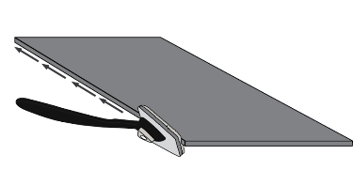
Starting at one side of the panel, angle the applicator away from the face of the panel. Simply run the applicator along the edge. Ensure full coverage of the edge. LUKO must fully cover the saw cuts. Repeat the process if necessary.

Any damage to the rear sealer of the panel may also be impregnated with LUKO.

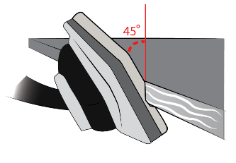
Finishing must be done sheet by sheet and not a stack all at once.

During application the applicator must be held slightly at an angle to prevent the liquid running on the visible side.

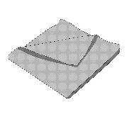
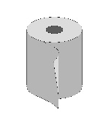
Surplus LUKO must be immediately removed with a cloth or paper towel to prevent staining the visible side.

Do not use micro fibre cloth that was used to remove the dust. Do not reuse a cloth as it may cause permanent streak marks and staining. The microfiber cloth can only be reused when thoroughly cleaned.

The complete impregnation of the cut edges of the façade panels prevents moisture absorption along the edges and any resulting temporary dark discoloration of the visible surfaces around the edges.

For special applications including, but not limited to, engraving and concealed fixings using Fischer FZP-K (Tergo+) or Keil Tergo systems, the engraved areas and penetrations will also need to be impregnated with LUKO.

3. Consumption
Approximately 0.5 l per 500 meter cut edge

4. Packaging
LUKO applicator toolkit | Art. No. 4084938
LUKO applicator replacement sponges (pack of 5) | Art. No. 4084939
Pot 0.5 l |  | Art. No. 202162
Pot 1 l |  | Art. No. 202329
Bucket 10 l |  | Art. No. 202426

5. Storage
Shelf life : 12 months after filling date

Disclaimer
The information in this document is correct at time issuing. However, due to our committed program of continuous material and system development we reserve the right to amend or alter the information contained therein without prior notice. Please visit www.equitone.com to ensure you have the most current version. All figures contained in this document are illustrations and should not be used as construction drawings. This information is supplied in good faith and no liability can be accepted for any loss or damage resulting from its use. This document is protected by international copyright laws. Reproduction and distribution in whole or in part without prior written permission is strictly prohibited. EQUITONE and logos are trademarks of Etex NV or an affiliate thereof. Any use without authorisation is strictly prohibited and may violate trademark laws.

It is also possible to apply LUKO to the cut edges of [pictura] and [textura] to prevent any possible risk of whitening of the edges (efflorescence).

