Product description
Decorative anodized aluminium corner trim for façade with EQUITONE.

ARTICLE NUMBER: 4037327

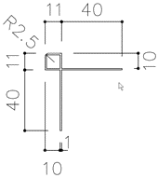
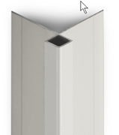
1. Technical Characteristics
Dimensions | see detailed drawing
Length |  | 3 m
Thickness |  | 1.4 mm
Colour |  | grey (anodized)
Substrate |  | Aluminium
International alloy name |  | EN AW 6060
Coating |  | E6 EV1 20µ
Protection foil |  | No

2. Packaging
Bundle of 5 pieces

3. Processing
Consult the application guidelines for EQUITONE.
Disclaimer
The information in this document is correct at time issuing. However, due to our committed program of continuous material and system development we reserve the right to amend or alter the information contained therein without prior notice. Please visit www.equitone.com to ensure you have the most current version. All figures contained in this document are illustrations and should not be used as construction drawings. This information is supplied in good faith and no liability can be accepted for any loss or damage resulting from its use. This document is protected by international copyright laws. Reproduction and distribution in whole or in part without prior written permission is strictly prohibited. EQUITONE and logos are trademarks of Etex NV or an affiliate thereof. Any use without authorisation is strictly prohibited and may violate trademark laws.

