Product description
Perforated closures to prevent entry of birds and vermin in the cavity. Used for façades with EQUITONE.

ARTICLE NUMBER: 40/30 : natural 4054138 – black 4071097
50/30 : natural 4006485 – black 4071098
70/30 : natural 4006486 – black 4071099
100/30 : natural 4006488 – black 4071100

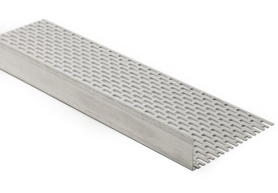
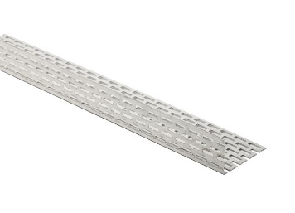
1. Technical characteristics
Dimensions |  | 40/30 mm, 50/30 mm, 70/30 mm, 100/30 mm
Length |  |  |  |  |  | 2.50 m
Thickness |  |  |  |  |  | 0.8 mm
Colour |  |  |  | natural aluminium or black aluminium
Type-dimensions | Perforation |  |  |  | Perforation surface |  | Perforation ratio
40/30 mm | both legs |  | long leg  short leg |  | 139 cm²/m  92 cm²/m |  | 34 %  30 %
50/30 mm | both legs |  | long leg  short leg |  | 185 cm²/m  92 cm²/m |  | 37 %  30 %
70/30 mm | long leg |  |  |  | 245 cm²/m |  | 36 %
100/30 mm | long leg |  |  |  | 393 cm²/m |  | 39 %

2. Packaging
Packaging | Per piece

3. Processing
Read the application guidelines for EQUITONE before installation.
Disclaimer
The information in this document is correct at time issuing. However, due to our committed program of continuous material and system development we reserve the right to amend or alter the information contained therein without prior notice. Please visit www.equitone.com to ensure you have the most current version. All figures contained in this document are illustrations and should not be used as construction drawings. This information is supplied in good faith and no liability can be accepted for any loss or damage resulting from its use. This document is protected by international copyright laws. Reproduction and distribution in whole or in part without prior written permission is strictly prohibited. EQUITONE and logos are trademarks of Etex NV or an affiliate thereof. Any use without authorisation is strictly prohibited and may violate trademark laws.

