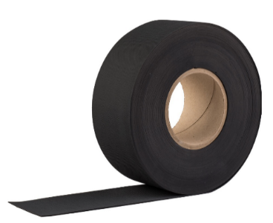
Product description
The EQUITONE EPDM tape is a non-reinforced EPDM waterproofing. The product is black and has a textured surface on both sides. It is used to protect the battens against permanent moisture penetration when fastening EQUITONE façade panels. Store in the original packaging in a cool, dry place. There are no restrictions on storage. Before installation, read the planning & application EQUITONE façade panels on timber support frame.

1. Technical characteristics
Width | 70 mm | 110 mm | 130 mm
Weight | 90.3 g/m | 141.9 g/m | 167.7 g/m
Article Nr. | 4010489 | 4010490 | 4030354
Thickness | 1 mm
Roll length | 20 m
Colour | Black
2. Technical data
Reaction to fire | EN 13501-1 | Class E
Watertightness (2 kPa) | EN 1928 B | Passed
Tear resistance  (Nail shank) | EN 12310-1 | 160 N
Elongation at rupture | EN 12311-2 (B) | 300 %
Tensile strength | EN 12311-2 (B) | 6 MPa
Durability (aging - 2 kPa) | EN 1296 / EN 1928 | Passed
Hazardous Substances | Construction Products Regulation | None

Disclaimer
The information in this document is correct at time issuing. However, due to our committed program of continuous material and system development we reserve the right to amend or alter the information contained therein without prior notice. Please visit www.equitone.com to ensure you have the most current version. All figures contained in this document are illustrations and should not be used as construction drawings. This information is supplied in good faith and no liability can be accepted for any loss or damage resulting from its use. This document is protected by international copyright laws. Reproduction and distribution in whole or in part without prior written permission is strictly prohibited. EQUITONE and logos are trademarks of Etex NV or an affiliate thereof. Any use without authorisation is strictly prohibited and may violate trademark laws.

