Product description
The EQUITONE EPDM tape is a non-reinforced EPDM waterproofing. The product is black and has a textured surface on both sides. It is used to protect the battens against permanent moisture penetration when fastening EQUITONE façade panels. Store in the original packaging in a cool, dry place. There are no restrictions on storage. Before installation, read the planning & application EQUITONE façade panels on timber support frame. The EPDM strip is UV resistant.

ARTICLE NUMBER: 4023320

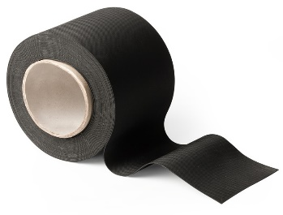
1. Technical characteristics
Dimensions |  |  |  | 100 mm
Thickness |  |  |  | 0.75mm (-5% / +10%)
Shape | Slightly structured surface
Weight |  |  |  | 90 ± 10 g/m
Surface |  | Homogeneous, pore free
Colour |  |  |  | Black
Hardness (ISO 7619) |  |  |  |  | 65°Shore A
Tensile strength (ISO 37) |  |  |  |  | Min. 8 Mpa
Elongation at rupture (ISO 37) |  |  |  |  | Min. 400 %
After aging for 7 days at 100 ° C (ISO 188)
Change in hardness |  |  |  |  | +2° Shore A
Change in tensile strength |  |  |  |  | +6 %
Change in elongation at break |  |  |  |  | -18 %
Ozon resistance
200PPHM/40°/20%/7d (ISO 1431/1) |  |  |  |  | No deterioration
Dimensional stability
24 hrs/100°C (DIN 7864) |  |  |  |  | Max. 0.5 %

2. Packaging
20 m per roll

Disclaimer
The information in this document is correct at time issuing. However, due to our committed program of continuous material and system development we reserve the right to amend or alter the information contained therein without prior notice. Please visit www.equitone.com to ensure you have the most current version. All figures contained in this document are illustrations and should not be used as construction drawings. This information is supplied in good faith and no liability can be accepted for any loss or damage resulting from its use. This document is protected by international copyright laws. Reproduction and distribution in whole or in part without prior written permission is strictly prohibited. EQUITONE and logos are trademarks of Etex NV or an affiliate thereof. Any use without authorisation is strictly prohibited and may violate trademark laws.

