Product description
Designed for cutting fibre-cement.

ARTICLE NUMBER: 4006696

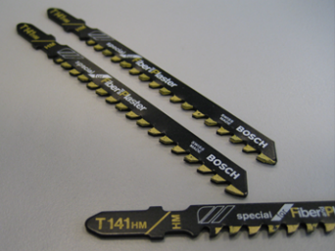
1. Technical characteristics
Carbide teeth are designed for long-term use on highly abrasive mineral-based materials
Teeth welded on highly flexible carbon steel
Large tooth spacing (4.3 mm) and long length (100 mm)

2. Packaging
Per 3 pieces

Disclaimer
The information in this document is correct at time issuing. However, due to our committed program of continuous material and system development we reserve the right to amend or alter the information contained therein without prior notice. Please visit www.equitone.com to ensure you have the most current version. All figures contained in this document are illustrations and should not be used as construction drawings. This information is supplied in good faith and no liability can be accepted for any loss or damage resulting from its use. This document is protected by international copyright laws. Reproduction and distribution in whole or in part without prior written permission is strictly prohibited. EQUITONE and logos are trademarks of Etex NV or an affiliate thereof. Any use without authorisation is strictly prohibited and may violate trademark laws.

