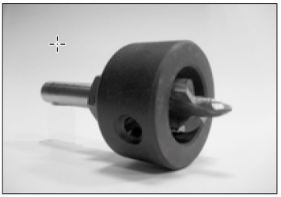
Product description
Designed for milling and drilling EQUITONE [linea] fibre-cement façade panels when visibly fixed on metal (aluminium or galvanised) support frame.

ARTICLE NUMBER: 4050773

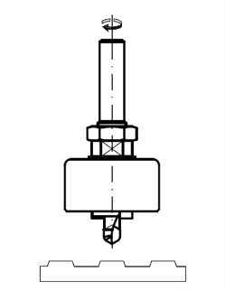
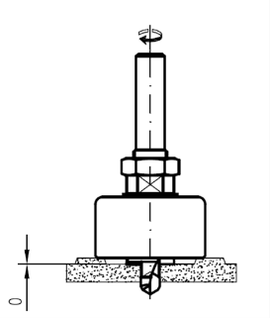
1. Technical characteristics
Diameter drill |  |  | 11 mm
Diameter mill |  |  | 20 mm
Diameter stop ring |  |  | 46 mm
Adjustable depth of mill part by control nut
Used on portable drill machine
Material
Drill |  | Solid Carbide
Stop ring | non-marking material

2. Packaging
Per piece in a plastic telescopic tube

Disclaimer
The information in this document is correct at time issuing. However, due to our committed program of continuous material and system development we reserve the right to amend or alter the information contained therein without prior notice. Please visit www.equitone.com to ensure you have the most current version. All figures contained in this document are illustrations and should not be used as construction drawings. This information is supplied in good faith and no liability can be accepted for any loss or damage resulting from its use. This document is protected by international copyright laws. Reproduction and distribution in whole or in part without prior written permission is strictly prohibited. EQUITONE and logos are trademarks of Etex NV or an affiliate thereof. Any use without authorisation is strictly prohibited and may violate trademark laws.

